**CSE2004 – Database Management Systems Registration Number :**

**Name :**

**Slot :**

**Mobile Number :**

**8**

**1**

**44935349**

**RDBMS used : Oracle**

**Cycle Sheet No. : 02**

# Creating Tables

Create table Doctor(

doc_id varchar(20) primary key, doc_name varchar(30) not null, d_gender char(1),

constraint ck_d_gender check(d_gender = 'M' or d_gender = 'F' or d_gender = 'T'),

d_dob date not null, specialist varchar(25), qualification varchar(15), d_Contact number(20),

d_Address varchar(50) not null, d_dept_no varchar(20)

);

create table Department( dept_no varchar(20) primary key, dept_name varchar(30) not null, room_no varchar(10),

floor number(5), hod varchar(20),

constraint fk_hod foreign key(hod) references Doctor(doc_id), estd_date date

);

create table Staff(

staff_id varchar(15) primary key, staff_name varchar(25) not null, category varchar(20), designation varchar(15) not null, s_dob date not null,

s_contact number(15), s_address varchar(50), s_dept_no varchar(10),

constraint fk_s_dept_no foreign key(s_dept_no) references Department(dept_no)

);

create table Patient(

pat_id varchar(20) primary key, pat_name varchar(30) not null, p_dob date not null,

p_gender varchar(10) not null,

constraint ck_p_gender check(p_gender = 'M'or p_gender = 'F' or p_gender

='T'),

p_contact number(20), p_address varchar(50) not null

);

create table In_Patient( ip_id varchar(20),

doa date not null, primary key(ip_id,doa), bed_no varchar(10),

start_time date, end_time date,

constraint fk_ip_id foreign key (ip_id) references Patient(pat_id)

);

create table Appointment( app_id varchar(20) primary key, a_pat_id varchar(20),

constraint fk_a_pat_id foreign key(a_pat_id) references Patient(pat_id), a_doc_id varchar(20),

constraint fk_a_doc_id foreign key(a_doc_id) references Doctor(doc_id), nurse_id varchar(20),

constraint fk_nurse_id foreign key(nurse_id) references Staff(staff_id), consult_room_no number(20),

a_date date not null, a_time varchar(10) not null

);

create table Prescription( pres_id varchar(15) primary key, p_app_id varchar(20),

constraint fk_p_app_id foreign key(p_app_id) references Appointment(app_id),

pres_date date not null, pres_time varchar(10), diagnosis_details varchar(20)

);

create table In_Patient_Prescription( in_pat_id varchar(20) not null,

ip_pres_id varchar(20) not null, primary key(in_pat_id,ip_pres_id),

constraint fk_pres_id foreign key(ip_pres_id) references Prescription(pres_id), constraint fk_in_pat_id foreign key(in_pat_id) references Patient(pat_id)

);

create table Prescribed_Medicines( m_pres_id varchar(25) ,

constraint fk_m_pres_id foreign key (m_pres_id) references Prescription(pres_id),

medicine_name varchar(40) not null, primary key(m_pres_id,medicine_name), dosage varchar(20),

brand varchar(10)

);

create table Hospital_Bill( inv_no number(20), inv_date date not null,

primary key(inv_no,inv_date), i_pat_id varchar(20),

constraint fk_i_pat_id foreign key(i_pat_id) references Patient(pat_id), bill_amount number(25),

payment_type varchar(25) not null, discount number(20)

);

create table Lab_Tests(

test_id varchar(20) primary key,

L_pat_id varchar(20),

constraint fk_L_pat_id foreign key(L_pat_id) references Patient(pat_id), lab_date date,

lab_time varchar(10)

);

create table test_types(

tt_id varchar(20) primary key, description varchar(30), low_value number(25), high_value number(25), test_method varchar(25), technician varchar(20),

constraint fk_technician foreign key(technician) references Staff(staff_id)

);

create table Test_Results( r_test_id varchar(20) ,

constraint fk_r_test_id foreign key (r_test_id) references Lab_Tests(test_id), r_test_type_id varchar(20),

constraint fk_r_test_type_id foreign key(r_test_type_id) references test_types(tt_id),

primary key(r_test_id,r_test_type_id), results varchar(20) not null

);

# Inserting Values

insert into Doctor values('D108','PRADEEP KUMAR','M','20-SEPTEMBER- 1985','CARDIOLOGIST','MBBS',9926519823,'1,BAREILLY','D101');

insert into Doctor values('D105','MAHENDRA GANGWAR','M','12-FEBRUARY- 1980','NEUROLOGIST','BAMS',9254376189,'15,LUCKNOW','D103');

insert into Doctor values('D101','MAHIPAL JOSHI','F','21-AUGUST- 1989','NEPHROLOGIST','MD',976124512,'51,KANPUR','D101');

insert into Doctor values('D107','AMAN SINGH','M','01-JANUARY- 1992','ONCOLOGIST','MD',8449268172,'95,AGRA','D190');

insert into Doctor values('D104','PAWAN GANGWAR','M','21-DECEMBER- 1991','GENERALMEDICINE','MD',8912678219,'102,PUNE','D101');

insert into Doctor values('D102','TANU GANGWAR','F','25-JUNE- 1990','CARDIOLOGIST','MBBS',9363981256,'530,DELHI','D100');

insert into Doctor values('D106','Raghavan','M','03-FEBRUARY- 1994','NEPHROLOGIST','MDS',9897268266,'17,MATHURA','D101');

insert into Doctor values('D103','RIYA PATEL','F','25-APRIL- 1984','CARDIOLOGIST','MD',7904226737,'121,GWALIOR','D005');

insert into Department values('D101','CARDIOLOGY','A-111',7,'D108','20- MARCH-2012');

insert into Department values('D103','NEUROLOGY','A-120',5,'D101','10- JANUARY-2011');

insert into Department values('D190','ONCOLOGY','A-005',9,'D105','19- DECEMBER-2019');

insert into Department values('D100','CARDIOLOGY','C-050',7,'D106','21-APRIL- 2019');

insert into Department values('D005','GM','D-110',7,'D104','31-DECEMBER- 2011');

insert into Staff values('S0001','KIRTI','nurse','staff nurse','18-AUGUST- 1998',9421862561,'BAREILLY','D101');

insert into Staff values('S0002','SWATI GANGWAR','nurse','staff nurse','05- SEPTEMBER-1999',9721765571,'LUCKNOW','D103');

insert into Staff values('S0003','SHIVANI MAURYA','nurse','staff nurse','10- JUNE-1995',9421862561,'AGRA','D005');

insert into Staff values('S0004','VIRAT SINGH','lab technician','technician','15- APRIL-1997',978945121,'MATHURA','D190');

insert into Staff values('S0005','ROHIT KASHYAP','lab technician','technician','18-DECEMBER-1998',978951124,'PILIBHIT','D190');

insert into Staff values('S0006','DEEPANSHU GANGWAR','cashier','staff cashier','11-DECEMBER-1994',9421862561,'MUMBAI','D101');

insert into Staff values('S0008','MANOJ KUMAR','ward boy','ward boy','29- AUGUST-1992',9787862561,'DELHI','D103');

insert into Staff values('S0009','YASH JAISWAL','security','staff security','06- DECEMBER-1996',9421862561,'GURGAON','D005');

insert into Patient values('P101','SAKSHAM PATEL','06-JULY- 2000','M',9218357319,'52,BAREILLY');

insert into Patient values('P220','TANUJ','09-OCTOBER- 1978','F',7841454511,'132,MUMBAI');

insert into Patient values('P103','Steve ','20-DECEMBER- 1975','M',9751254454,'08,DELHI');

insert into Patient values('P104','Mani','15-JUNE- 1995','M',944587122,'62,JHANSI');

insert into Patient values('P105','FARIA NOORI','19-DECEMBER- 2014','F',9878987890,'12,GWALIOR');

insert into Patient values('P106','Gayle','25-MARCH- 1990','M',944548412,'102,MATHURA');

insert into Patient values('P107','MANSI JAISWAL','07-JUNE- 1994','F',9785458412,'190,BAREILLY');

insert into Patient values('P108','Karthik','21-AUGUST- 1979','M',944548412,'06,KANPUR');

insert into In_Patient values('P101', '11-MARCH-2017','B101','11-MARCH- 2017','18-MARCH-2017');

insert into In_Patient values('P220', '10-JANUARY-2020' ,'B012','10-JANUARY- 2020','30-JANUARY-2020');

insert into In_Patient values('P104', '28-FEBRUARY-2020' ,'B101','28- FEBRUARY-2020','15-MARCH-2020');

insert into In_Patient values('P105', '30-MARCH-2017','B015','30-MARCH- 2017','09-APRIL-2017');

insert into In_Patient values('P106', '30-DECEMBER-2019','B001','30- DECEMBER-2019','15-JANUARY-2020');

insert into In_Patient values('P107','30-MARCH-2020','B019','30-MARCH- 2020','17-APRIL-2020');

insert into In_Patient values('P103','29-MAY-2020','B101','29-MAY-2020','12- JUNE-2020');

insert into In_Patient values('P108','30-NOVEMBER-2019','B14','30- NOVEMBER-2019','30-DEC-2019');

insert into Appointment values('A101','P101','D101','S0001',103,'12-MARCH- 2017','13:00');

insert into Appointment values('A102','P220','D102','S0002',111,'11-JANUARY- 2020','12:00');

insert into Appointment values('A103','P103','D103','S0003',100,'01-JANUARY- 2020','17:00');

insert into Appointment values('A104','P104','D104','S0004',005,'18- FEBRUARY-2020','11:00');

insert into Appointment values('A105','P105','D105','S0005',120,'25-AUGUST- 2019','08:00');

insert into Appointment values('A106','P106','D106','S0006',111,'01-MAY- 2020','09:30');

insert into Appointment values('A107','P107','D107','S0008',111,'01-MAY- 2020','10:15');

insert into Appointment values('A108','P108','D108','S0009',105,'01-MAY- 2020','11:20');

insert into Prescription values('PR00001','A101', '12-MARCH-2017'

,'13:30','COUGH');

insert into Prescription values('PR00002','A102', '11-JANUARY-2020'

,'13:00','NEURAL ATTACK');

insert into Prescription values('PR00003','A103','02-JANUARY- 2020','14:00','BILATERAL PNEUMONIA');

insert into Prescription values('PR00004','A104','18-FEBRUARY- 2020','16:00','COUGH');

insert into Prescription values('PR00005','A105','25-AUGUST- 2019','08:30','CARDIAC ARREST');

insert into Prescription values('PR00006','A106','01-MAY- 2020','10:15','ACCIDENT');

insert into Prescription values('PR00007','A107','01-MAY- 2020','11:25','COUGH');

insert into Prescription values('PR00008','A108','01-MAY- 2020','12:30','CARDIAC ARREST');

insert into In_Patient_Prescription values('P101','PR00001'); insert into In_Patient_Prescription values('P220','PR00002'); insert into In_Patient_Prescription values('P103','PR00003'); insert into In_Patient_Prescription values('P104','PR00004'); insert into In_Patient_Prescription values('P105','PR00005'); insert into In_Patient_Prescription values('P106','PR00006'); insert into In_Patient_Prescription values('P107','PR00007'); insert into In_Patient_Prescription values('P108','PR00008');

insert into Prescribed_Medicines values('PR00001','AMOXICILLIN','TWICE A DAY','Ranbaxy');

insert into Prescribed_Medicines values('PR00002','AMANTADINE','ONCE A DAY','DEF');

insert into Prescribed_Medicines values('PR00003','MACROLIDE','ONCE A DAY','Ranbaxy');

insert into Prescribed_Medicines values('PR00004','AMOXICILLIN','THRICE A DAY','XYZ');

insert into Prescribed_Medicines values('PR00005','LIDOCAINE','TWICE A DAY','JKL');

insert into Prescribed_Medicines values('PR00006','TYLENOL','ONCE A DAY','MNO');

insert into Prescribed_Medicines values('PR00007','AMOXICILLIN','THRICE A DAY','PQR');

insert into Prescribed_Medicines values('PR00008','LIDOCAINE','TWICE A DAY','Ranbaxy');

insert into Hospital_Bill values(1020,'18-MARCH- 2017','P101',10000,'CASH',12);

insert into Hospital_Bill values(1021,'30-JANUARY-2020','P220',200000,'CREDIT CARD',15);

insert into Hospital_Bill values(1022,'30-MAY-2020','P103',11000,'DEBIT CARD',20);

insert into Hospital_Bill values(1023,'28-FEBRUARY-2020','P104',15000,'DEBIT CARD',13);

insert into Hospital_Bill values(1024,'30-JANUARY-2020','P105',20000,'CREDIT CARD',05);

insert into Hospital_Bill values(1025,'09-APRIL-2017','P106',7000,'CASH',22); insert into Hospital_Bill values(1026,'17-APRIL-2020','P107',3500,'CASH',18);

insert into Hospital_Bill values(1027,'12-JUNE-2020','P108',42000,'DEBIT CARD',10);

insert into Hospital_Bill values(1028,'05-JUNE-2020','P103',2000,'DEBIT CARD',21);

insert into Hospital_Bill values(1029,'09-JUNE-2020','P103',15000,'DEBIT CARD',20);

insert into Lab_Tests values('T0001','P101','13-MARCH-2017','11:00'); insert into Lab_Tests values('T0002','P220','12-JANUARY-2020','09:00'); insert into Lab_Tests values('T0003','P103','03-JANUARY-2020','10:00'); insert into Lab_Tests values('T0004','P104','19-FEBRUARY-2020','09:30'); insert into Lab_Tests values('T0005','P105','26-AUGUST-2019','16:00'); insert into Lab_Tests values('T0006','P106','02-MAY-2020','17:00'); insert into Lab_Tests values('T0007','P107','03-MAY-2020','13:00'); insert into Lab_Tests values('T0008','P108','03-MAY-2020','14:00');

insert into test_types values('TT0001','URINE TEST',26,74,'LAB','S0001'); insert into test_types values('TT0002','CT',15,20,'LAB','S0002');

insert into test_types values('TT0003','Blood Sugar Level',18,28,'LAB','S0003'); insert into test_types values('TT0004','XRAY TEST',38,52,'LAB','S0001');

insert into test_types values('TT0005','CT TEST',12.5,14.2,'LAB','S0005'); insert into test_types values('TT0006','URINE TEST',12,22,'LAB','S0001'); insert into test_types values('TT0007','XRAY',19,29,'LAB','S0009');

insert into test_types values('TT0008','Blood Glucose Level',2,10,'LAB','S0008');

insert into Test_Results values('T0001','TT0001','POSITIVE'); insert into Test_Results values('T0002','TT0002','NEGATIVE'); insert into Test_Results values('T0003','TT0003','NEGATIVE'); insert into Test_Results values('T0004','TT0004','POSITIVE'); insert into Test_Results values('T0005','TT0005','NEGATIVE'); insert into Test_Results values('T0006','TT0006','NEGATIVE'); insert into Test_Results values('T0007','TT0007','POSITIVE'); insert into Test_Results values('T0008','TT0008','NEGATIVE');

I executed the alter queries at the end because for join the address of patient is asked and in alter query it is asked to remove address attributes.

# DDL statements (ALTER, CONSTRAINT etc)

## Modify Hospital_Bill by adding an attribute consulting_physician and add foreign key constraint for that attribute. Use constraint name for foreign key constraint.

alter table Hospital_Bill add consulting_physician varchar(15);

alter table Hospital_Bill add constraint fk_con_physician foreign key(consulting_physician) references Doctor(doc_id);

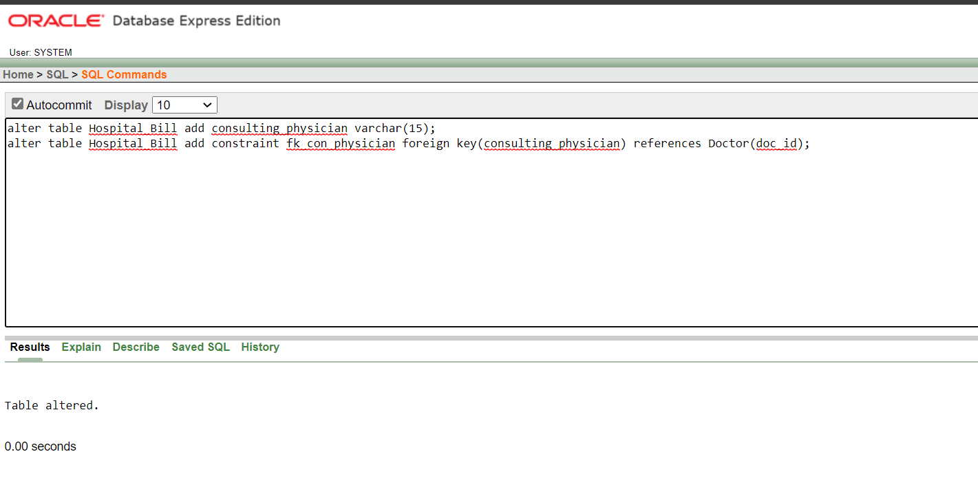

## In Patient table, replace address with three attributes namely street, city and pincode.

alter table Patient drop column p_address

alter table Patient add street varchar(20); alter table Patient add city varchar(15); alter table Patient add pincode number(6);

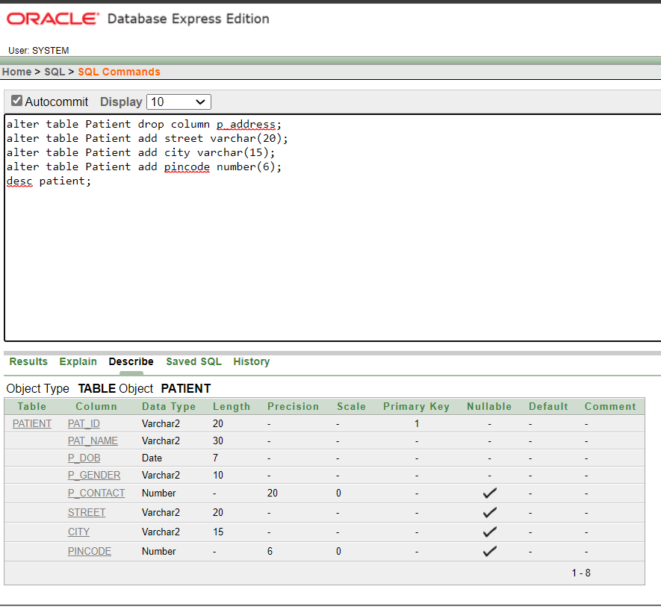

## Add an attribute Test_Time which can accept only two values “Before food” and “After food” with proper constraint name.

alter table Patient add Test_Time varchar(10);

alter table Patient add constraint ck_test_time check(Test_Time = 'Before food' or Test_Time = 'After food');

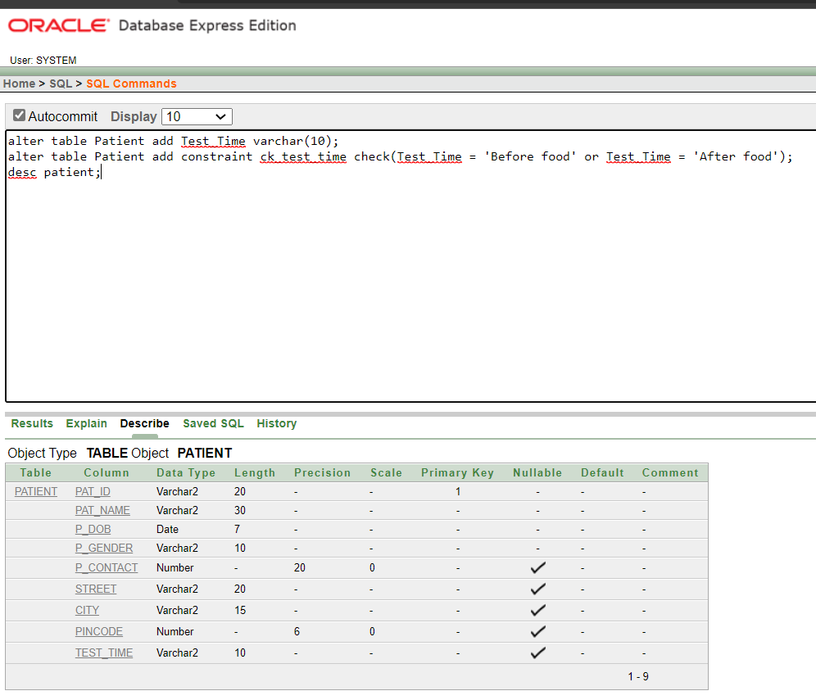

## Remove the constraint only from test_time attribute.

alter table Patient drop constraint ck_test_time;

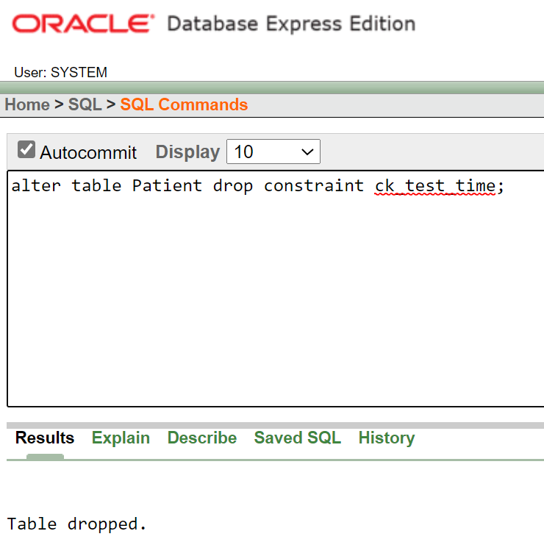

## Drop address attribute from staff table and add attributes door_no, street, city, and pincode.

alter table Staff drop column s_address; alter table Staff add door_no number(5); alter table Staff add street varchar(15); alter table Staff add city varchar(15); alter table Staff add pincode number(6);

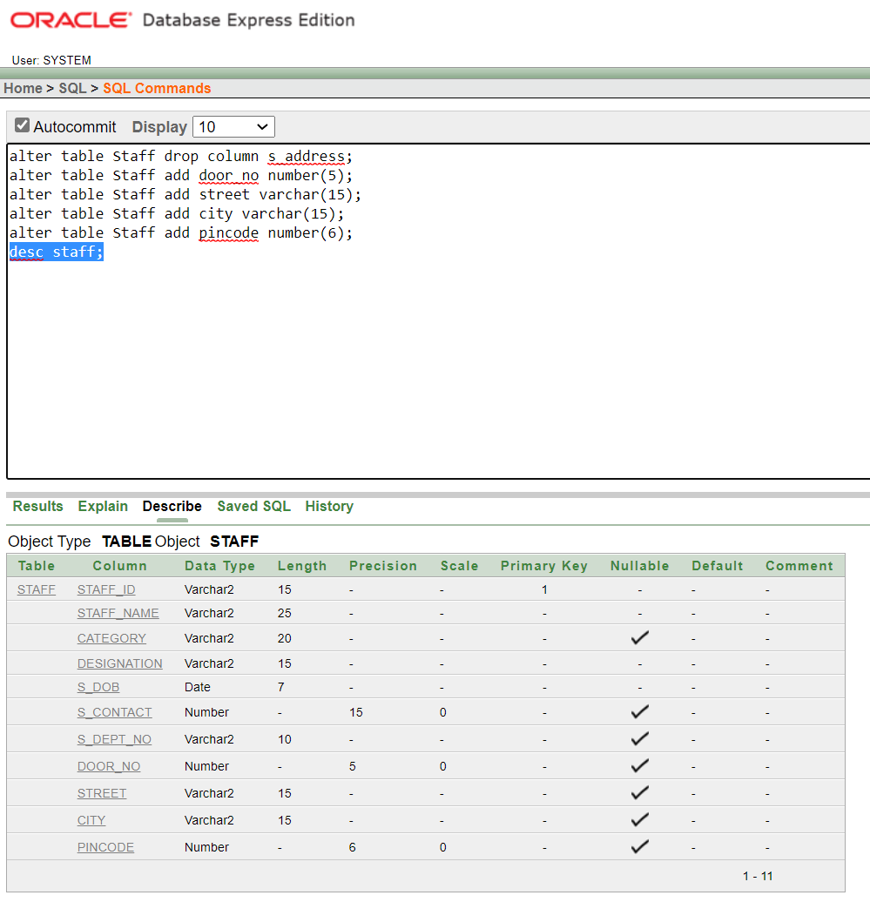

## Create a table Medicines with schema medicines=(med_name, brand, dosage, manu_date, exp_date). Ensure that manu_date should not be later than exp_date. Create an appropriate constraint to ensure this.

create table Medicines( med_name varchar(30), brand varchar(20), primary key(med_name), dosage varchar(25), manu_date date, exp_date date,

constraint ck_manu_date check( manu_date < exp_date)

);

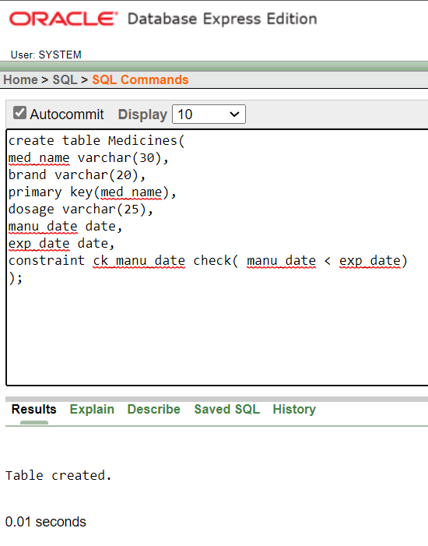

## Remove the attributes dosage and brand from Prescribed_Medicines and alter the medicine_name attribute as a foreign key referencing the new table Medicines.

alter table Prescribed_Medicines drop column dosage; alter table Prescribed_Medicines drop column brand;

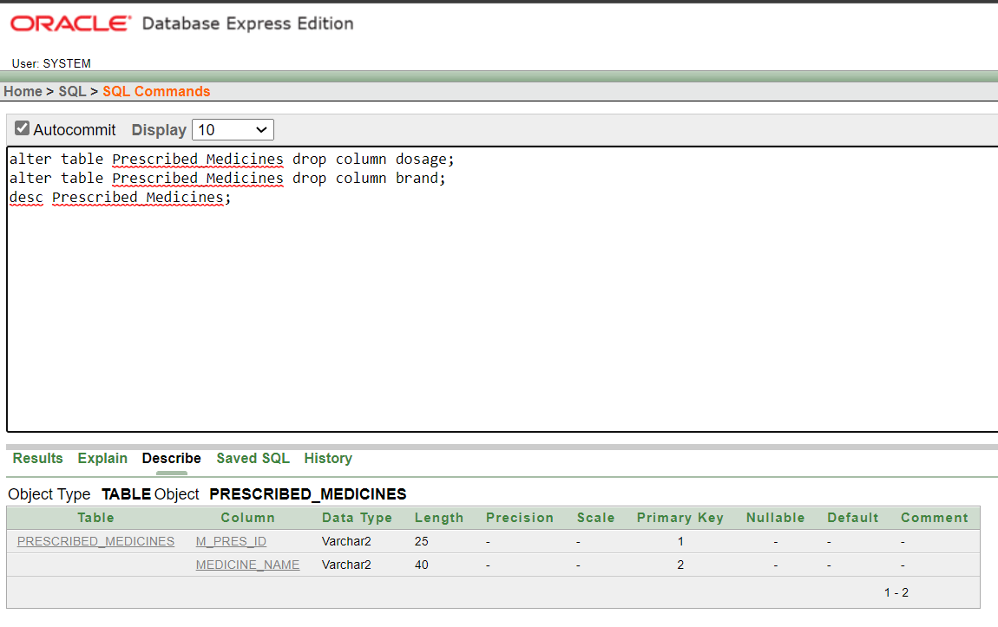

alter table Prescribed_Medicines add constraint fk_medicine_name foreign key(medicine_name) references Medicines(med_name);

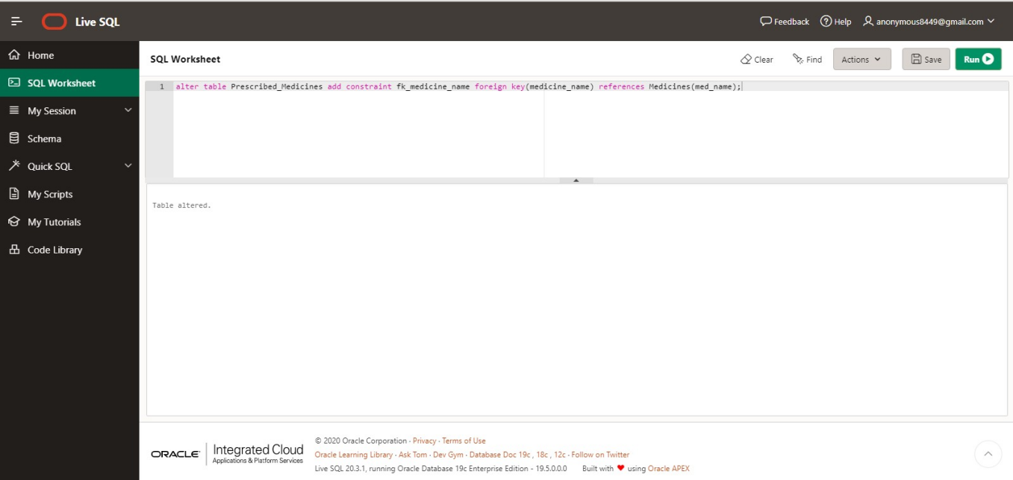

## Create a view for doctors who are specialized in ‘Cardiology’ from

**Doctor table with attributes doc_id, doc_name and gender.**

create view Cardiology_Doctors as select doc_id, doc_name, d_gender from Doctor where specialist = 'Cardiology';

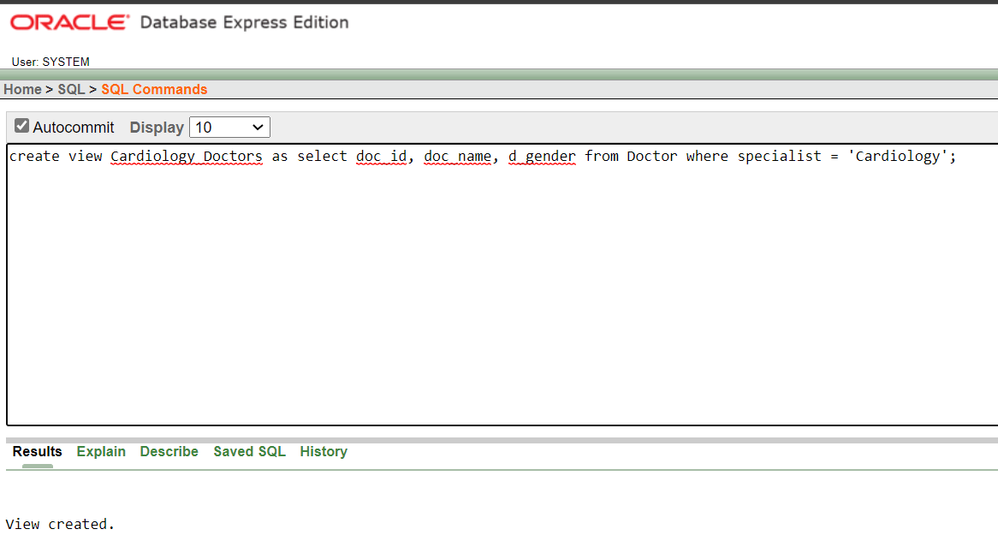

## Add an attribute No_of_staff in Department table and create a constraint with constraint name to make sure the number is >0

alter table Department add No_of_staff int;

alter table Department add constraint ck_no_of_staff check(No_of_staff > 0);

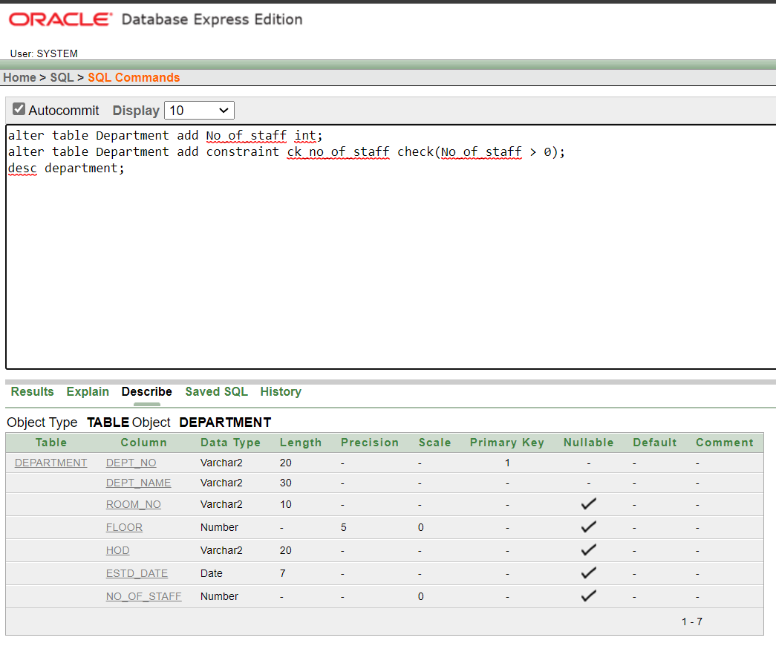

## Add an attribute with In_Patient_prescription to store the Room_Type

**which can store the values “AC” and “Non-AC”.**

alter table In_Patient_Prescription add Room_Type varchar(8);

alter table In_Patient_Prescription add constraint ck_Room_Type check(Room_Type = 'AC' or Room_Type = 'Non-AC');

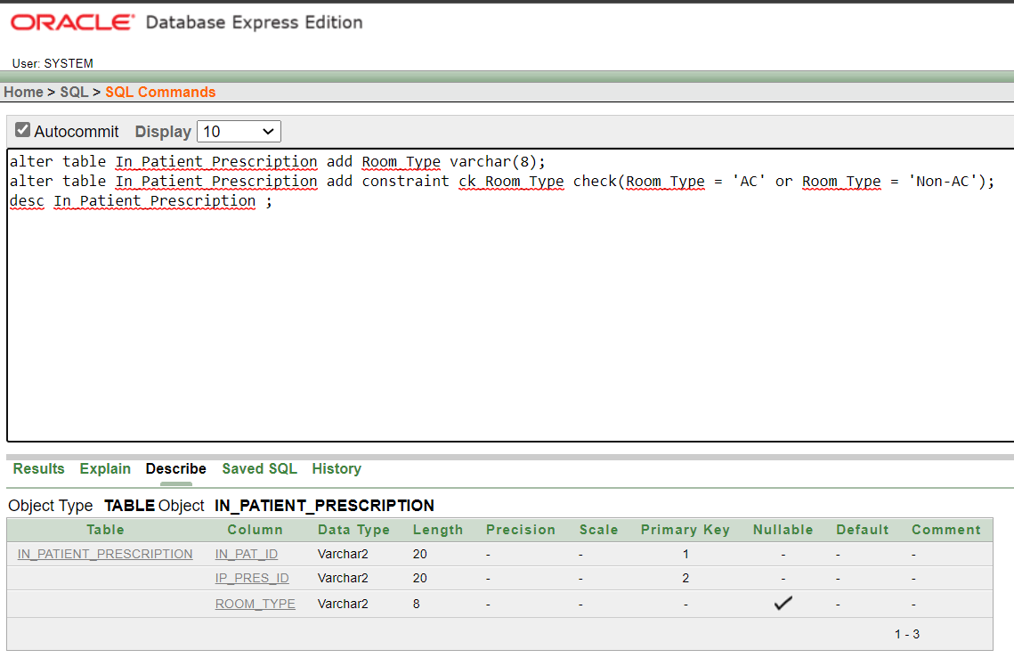

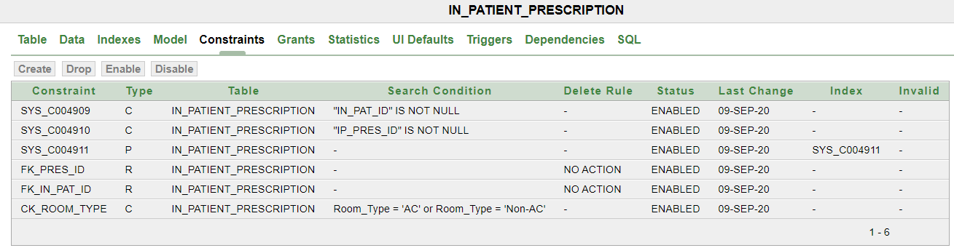

# SQL queries with JOIN operation

## Find the HOD of doctor ‘Raghavan’ (Hint: you need to join the tables

**DOCTOR and DEPARTMENT).**

**Using cartesian Product**

select hod from Department, Doctor where Department.dept_no = Doctor.d_dept_no and doc_name = 'Raghavan';

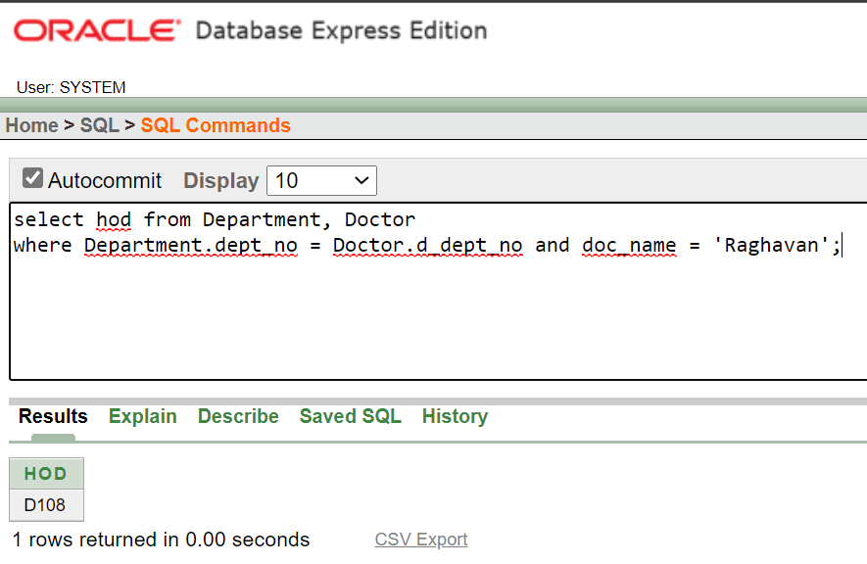

## Using Inner Join

select h.hod from Department h inner join Doctor d on d.d_dept_no = h.dept_no where d.doc_name = 'Raghavan';

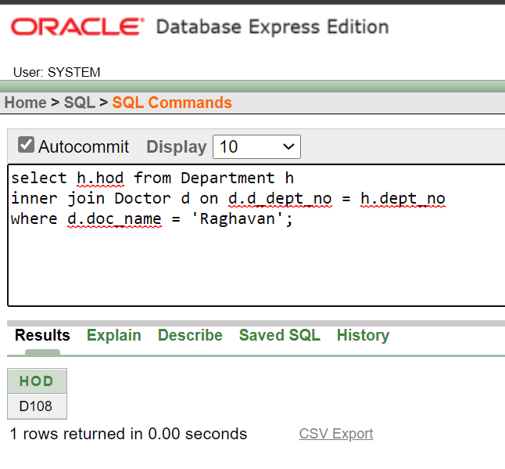

## Find the list of all patients who were admitted in bed number ‘B101’.

**Using Cartesian Product**

select pat_name from Patient,In_Patient where Patient.pat_id = In_Patient.ip_id and bed_no = 'B101';

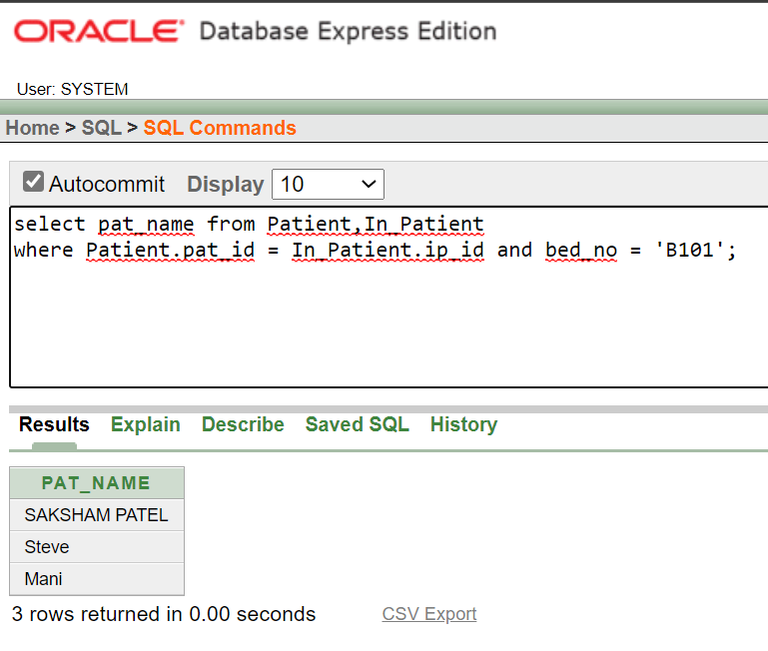

## Using Inner Join

select distinct p.pat_name from Patient p inner join In_Patient i on p.pat_id = i.ip_id and i.bed_no = 'B101';

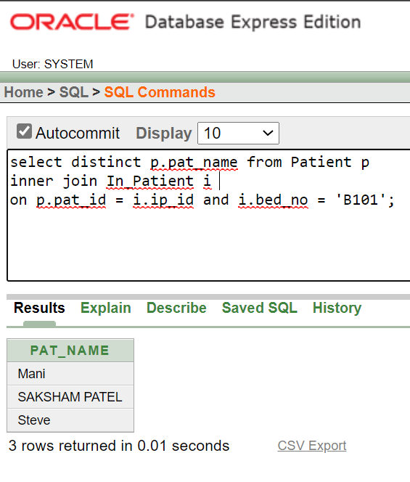

## Display all the prescribed medicines of patient with Pat_ID ‘P101’.

select distinct medicine_name from Prescribed_Medicines,Patient where Patient.pat_id = 'P101';

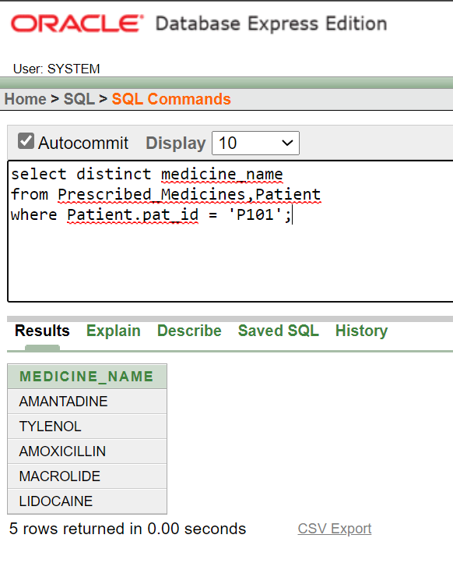

## Display the test results of patient ‘Mani’.

select results from Test_Results, Lab_Tests,Patient where Test_Results.r_test_id = Lab_Tests.test_id and Lab_Tests.l_pat_id = Patient.pat_id and pat_name = 'Mani';

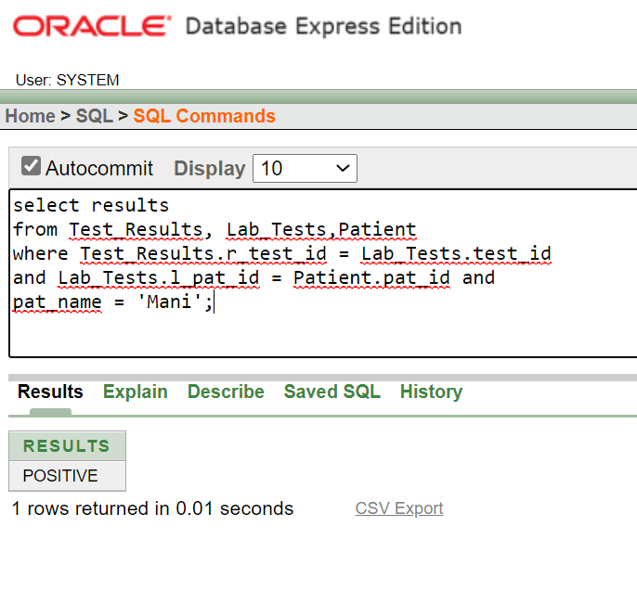

## Display all bills of bill amount more than 10000 rupees and paid by the

**patient ‘Steve’.**

select distinct b.bill_amount from Hospital_Bill b inner join Patient p on b.i_pat_id = 'P103' where b.bill_amount > 10000;

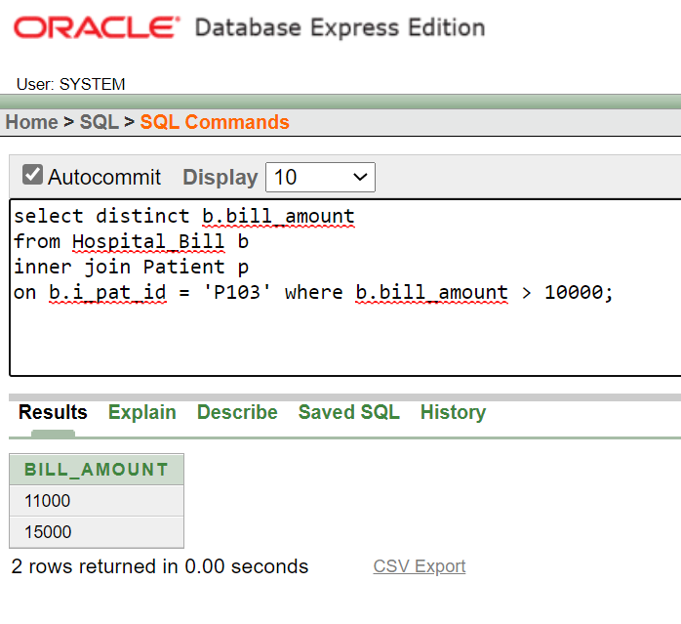

## Find the category and address of the nurse who attended the patient

**with pat_no ‘P220’.**

**Using Cartesian Product**

select category,s_address from Staff,Appointment

where Staff.staff_id = Appointment.nurse_id and Appointment.a_pat_id = 'P220';

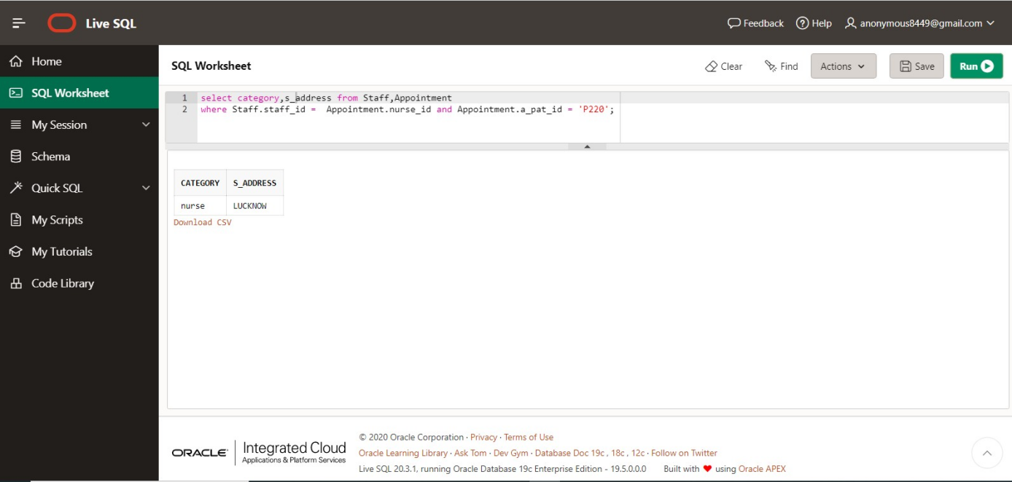

## Using Inner Join

select s.category, s.s_address from Staff s inner join Appointment a on s.staff_id = a.nurse_id where a.a_pat_id = 'P220';

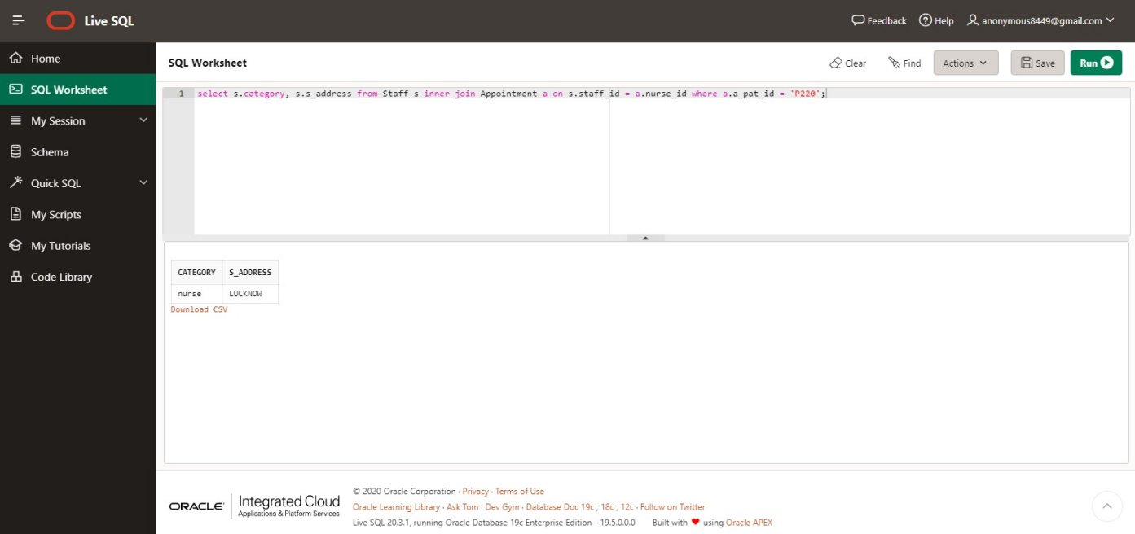

## Find the list of doctors who worked in the department which is started

**on or after ’10-May-2018’.**

**Using Cartesian Product**

select doc_name from Doctor,Department where Doctor.d_dept_no = Department.dept_no and estd_date >= '10-May-2018';

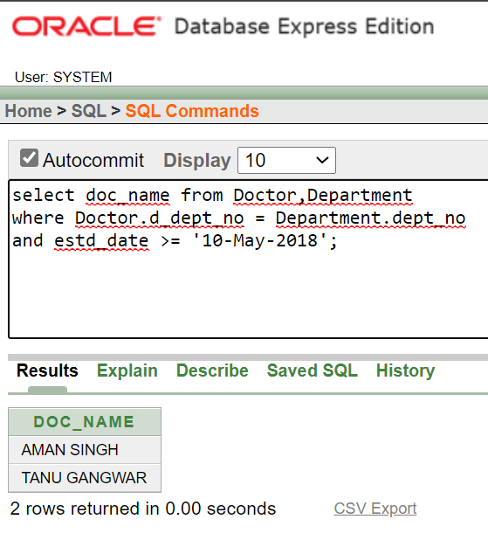

## Using Inner Join

select d.doc_name from Doctor d inner join Department w on d.d_dept_no = w.dept_no where w.estd_date >= '10-May-2018';

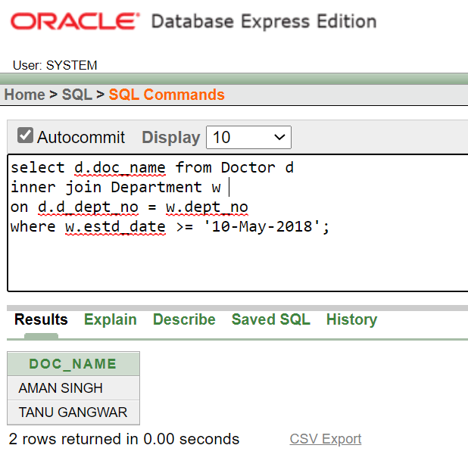

## Get the name of technicians who tests blood glucose level.

**Using Cartesian Product**

select staff_name from Staff,test_types

where test_types.technician = Staff.staff_id and description = 'Blood Glucose Level';

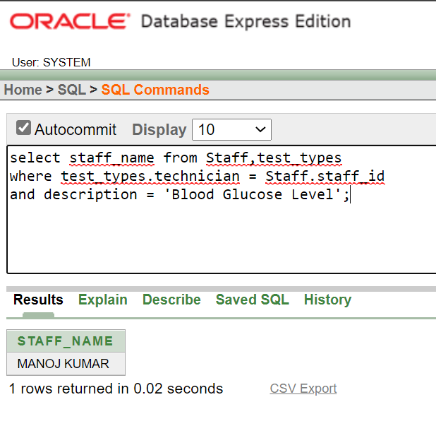

## Using Inner Join

select n.staff_name from Staff n inner join test_types t on t.technician = n.staff_id where t.description = 'Blood Glucose Level';

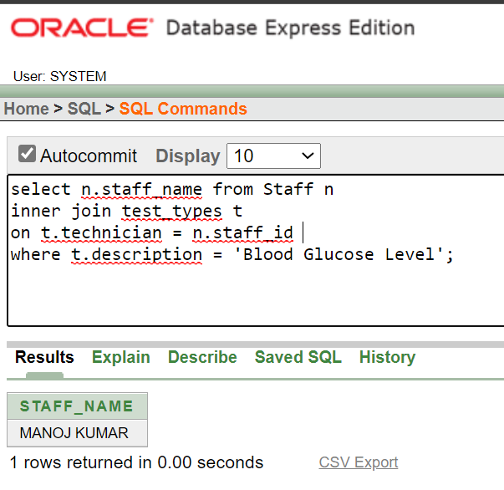

## Display the details of all patients who were hospitalized between ’10- Mar2017’ and ’10-Apr-2017’.

Select distinct *from In_Patient s, In_Patient e where s.doa > '10-Mar2017' and e.doa < '10-April-2017';

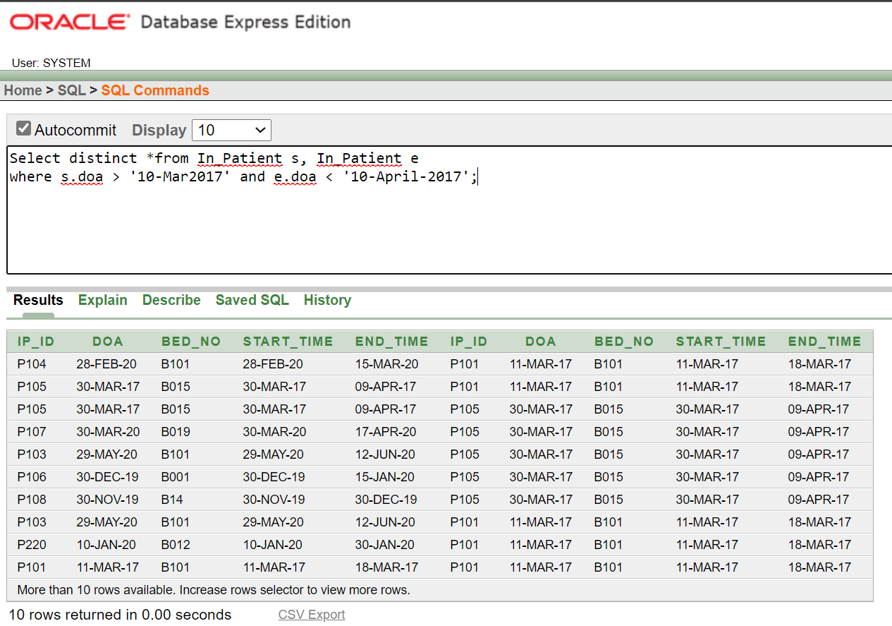

## Display the in-patient prescription of the patient whose name is

**‘Gayle’.**

**Using Cartesian Product**

select *from In_Patient_Prescription,Patient where In_Patient_Prescription.in_pat_id = Patient.pat_id and pat_name = 'Gayle';

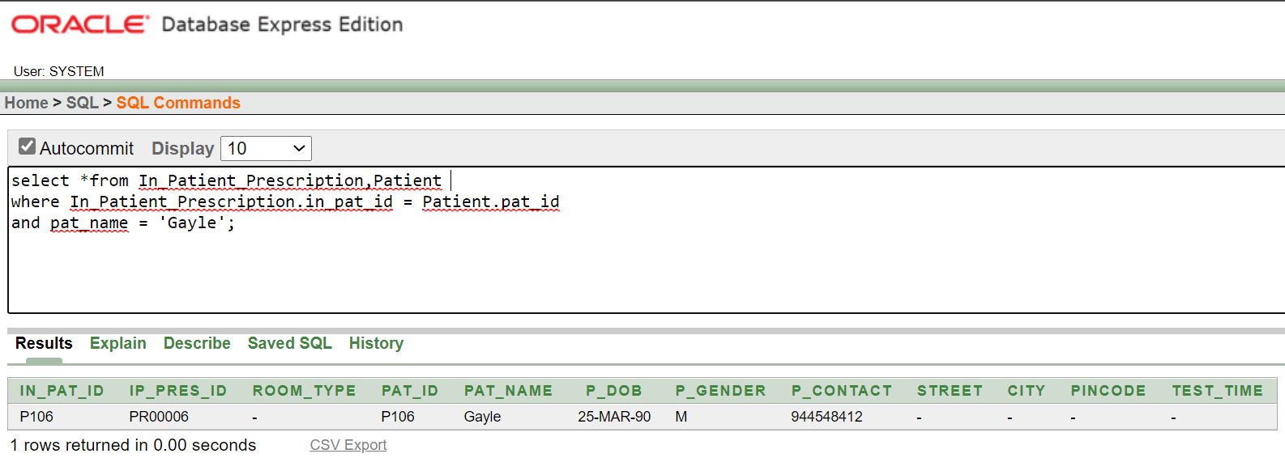

## Using Inner Join

select *from In_Patient_Prescription i inner join Patient p on i.in_pat_id = p.pat_id where p.pat_name = 'Gayle';

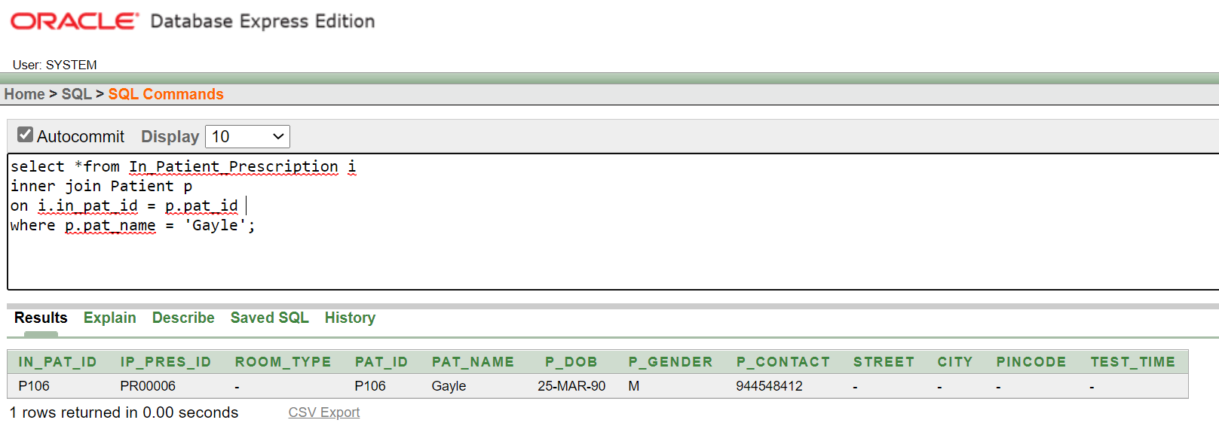

# SQL queries with AGGREGATE and CHAR functions

## Find the number of doctors who are working in the department ‘D101’

select count(*) as D101_Count from Doctor where d_dept_no = 'D101';

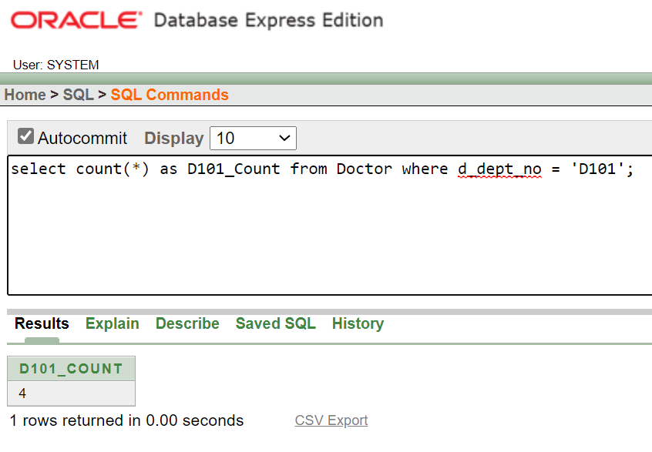

## Count the number of male patients who are treated by the doctor with

**doctor id ‘D101’**

select count(patient.p_gender) as male_patient_count from Patient,Appointment where Appointment.a_pat_id = Patient.pat_id and Appointment.a_doc_id = 'D101';

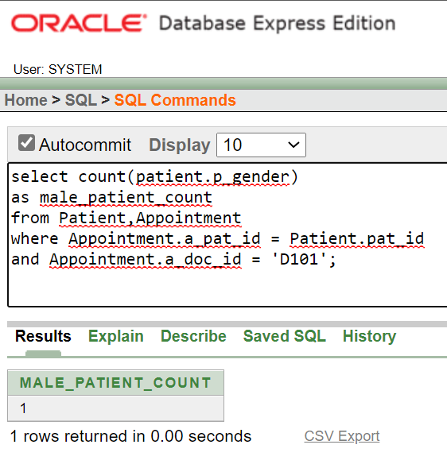

## Find the total bill paid by the patient ‘Karthik’.

select sum(Hospital_Bill.bill_amount) as total_bill_paid_by_karthik from Hospital_Bill,Patient where Hospital_Bill.i_pat_id = Patient.pat_id and pat_name = 'Karthik';

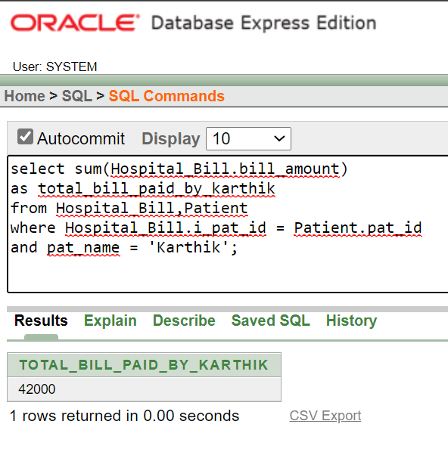

## Find the name and address of the patient who paid the highest bill of all patients.

select pat_name,p_address from Patient,Hospital_Bill where Patient.pat_id = Hospital_Bill.i_pat_id and Hospital_Bill.bill_amount = (select max(bill_amount) from Hospital_Bill);

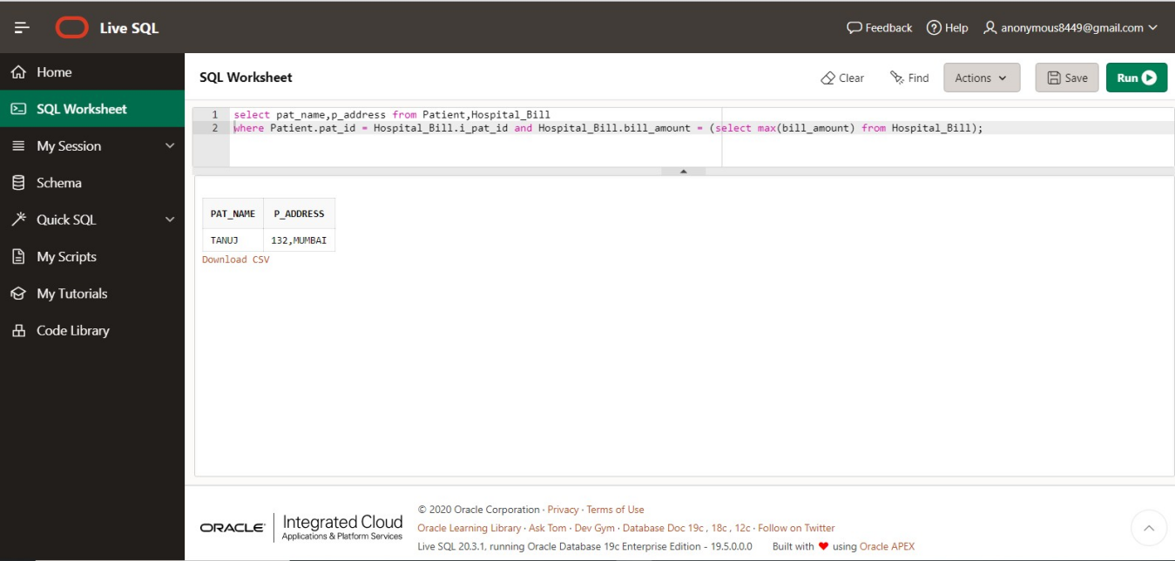

## Get the specialization of doctors whose name start with the letter ‘M’.

select specialist,doc_name from Doctor where doc_name like 'M%';

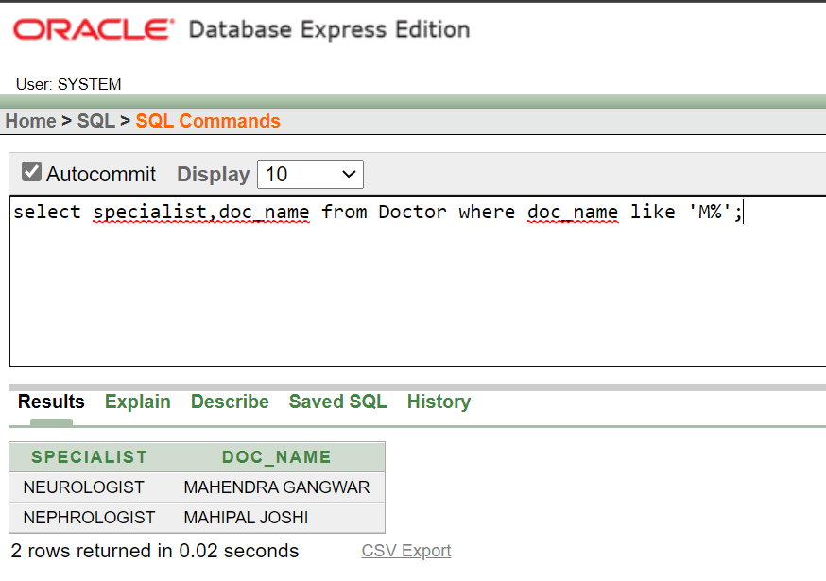

## Find the all the patients details whose name is exactly 5 characters long.

select *from Patient where pat_name like ' ';

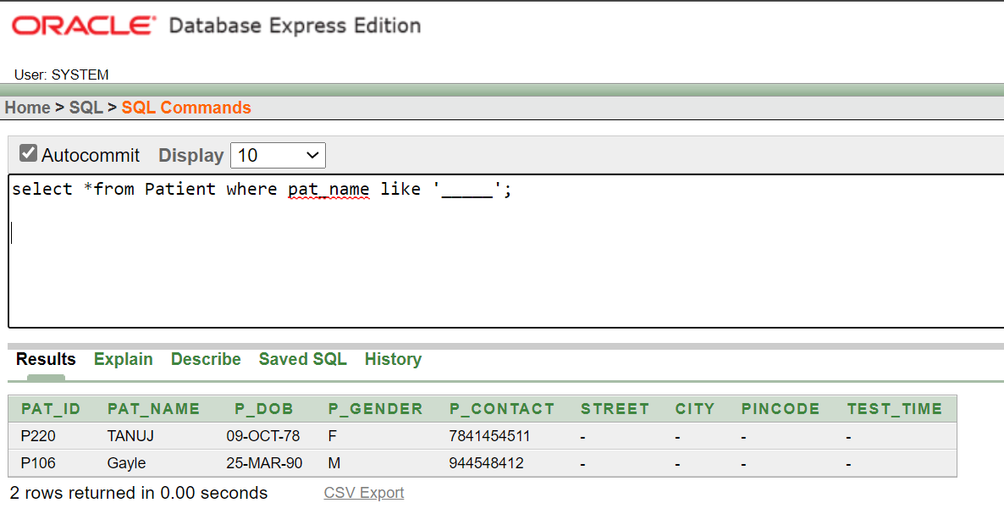

## Display the department names in ascending order.

select dept_name from Department order by dept_name asc;

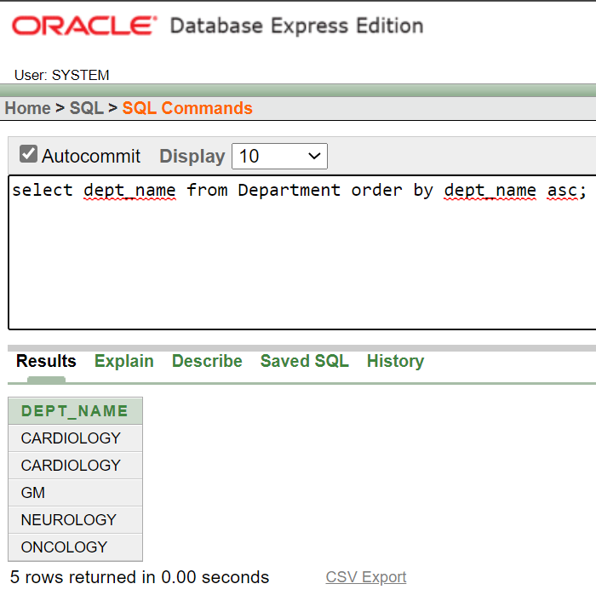

## Get the gender wise count of patients.

select count(p_gender ) as male_count from Patient where p_gender = 'M'; select count(p_gender) as female_count from Patient where p_gender = 'F'; select count(p_gender) as third_gender from Patient where p_gender = 'T';

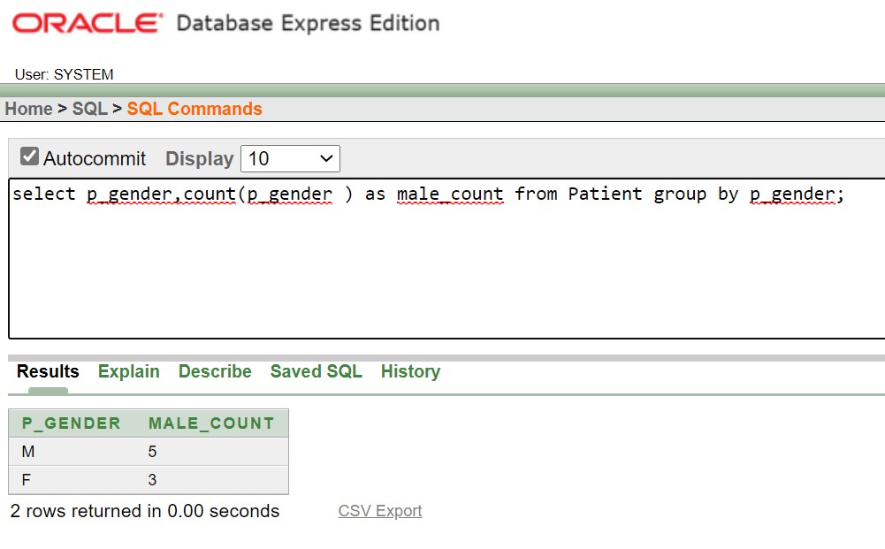

## Get the count of doctors for each specialization.

select specialist,count(specialist) as oncologist_count from Doctor group by specialist;

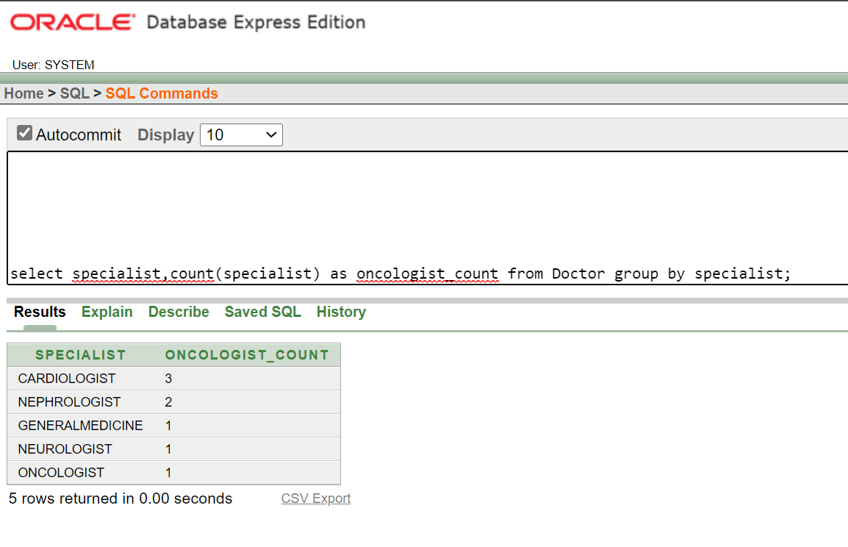

## Get the total number tests conducted in any particular date.

select count(l_pat_id) from Lab_Tests where lab_date = '03-MAY-2020';

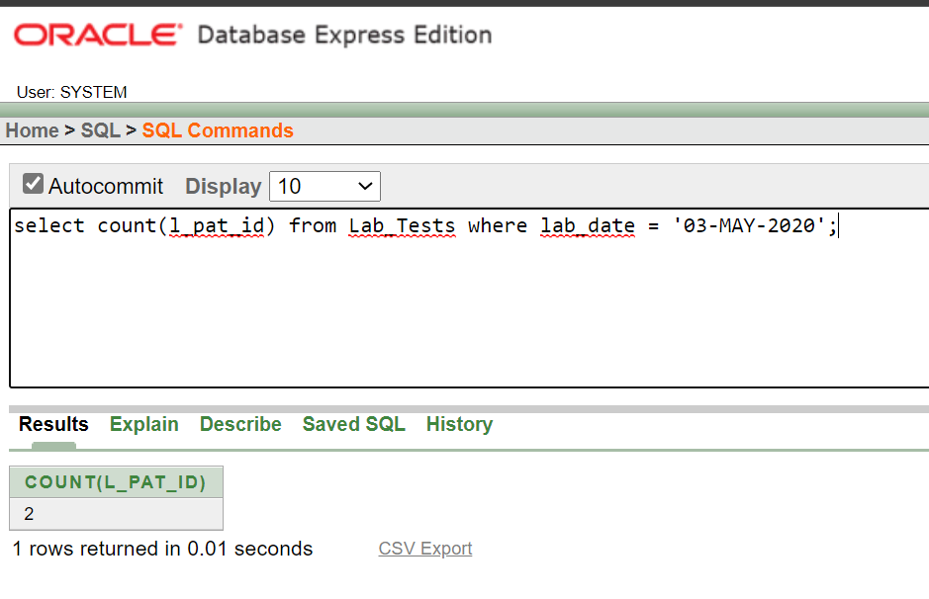

# SQL queries - Nested subqueries

## Q.1. . All of the queries in “SQL queries with JOIN operation” section can be

**tried with subqueries concept.**

1. **Find the HOD of doctor ‘Raghavan’ (Hint: you need to join the tables**

**DOCTOR and DEPARTMENT)**

select hod from Department where dept_no = (select d_dept_no from Doctor where doc_name = 'Raghavan');

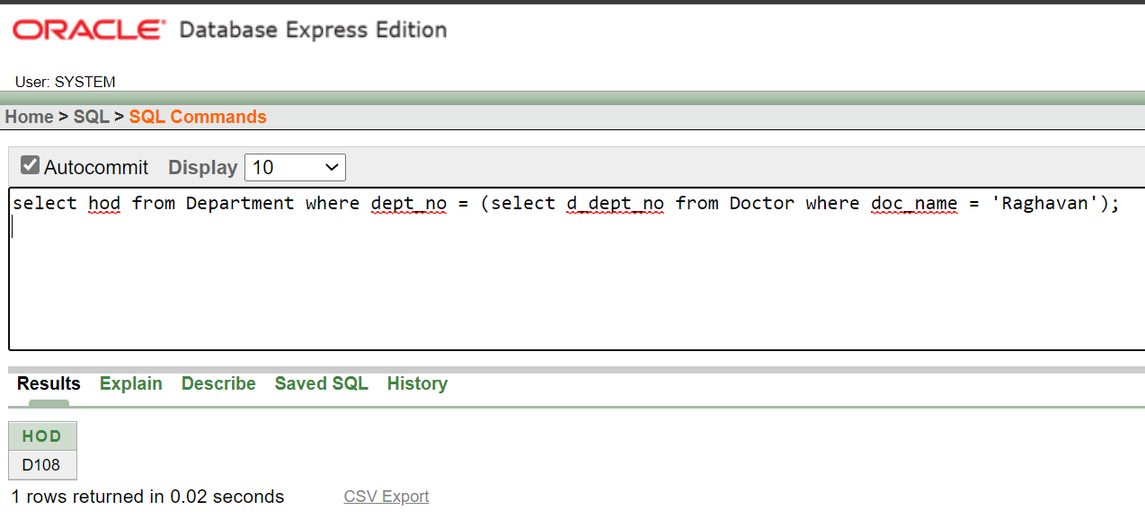

## Find the list of all patients who were admitted in bed number ‘B101’.

select pat_name from Patient where pat_id in (select ip_id from In_Patient where bed_no = 'B101');

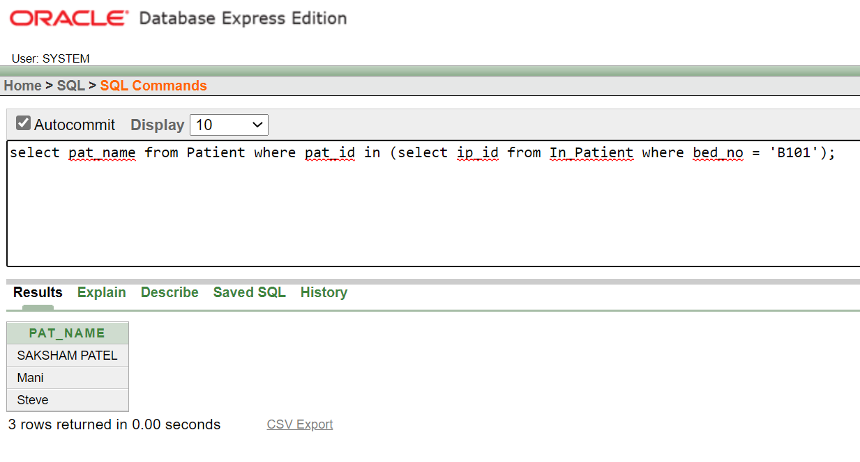

## Display all the prescribed medicines of patient with Pat_ID ‘P101’.

select medicine_name from Prescribed_Medicines where m_pres_id in (select ip_pres_id from In_Patient_Prescription where in_pat_id = 'P101');

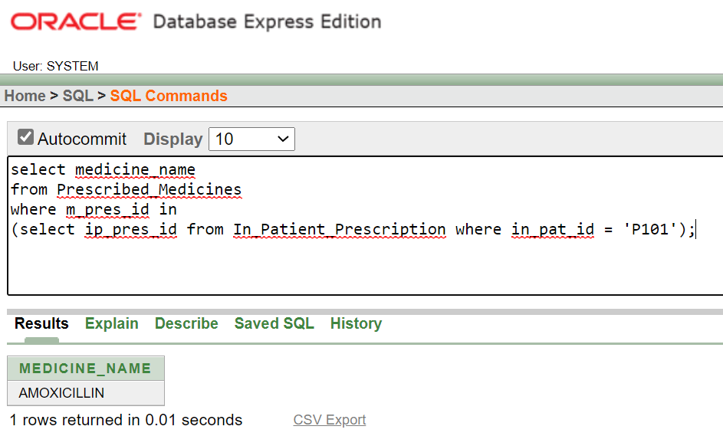

## Display the test results of patient ‘Mani’.

select results from Test_Results where r_test_id = (select test_id from Lab_Tests ,Patient where Lab_Tests.l_pat_id = Patient.pat_id and pat_name = 'Mani');

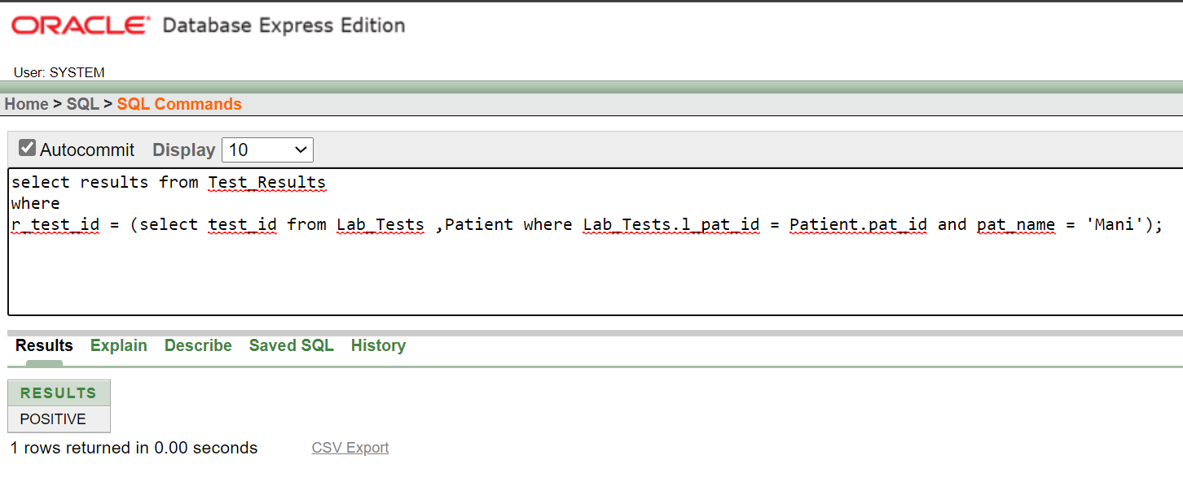

## Display all bills of bill amount more than 10000 rupees and paid by the

**patient ‘Steve’.**

select bill_amount from Hospital_Bill where i_pat_id = (select pat_id from Patient where pat_name = 'Steve') and bill_amount > 10000;

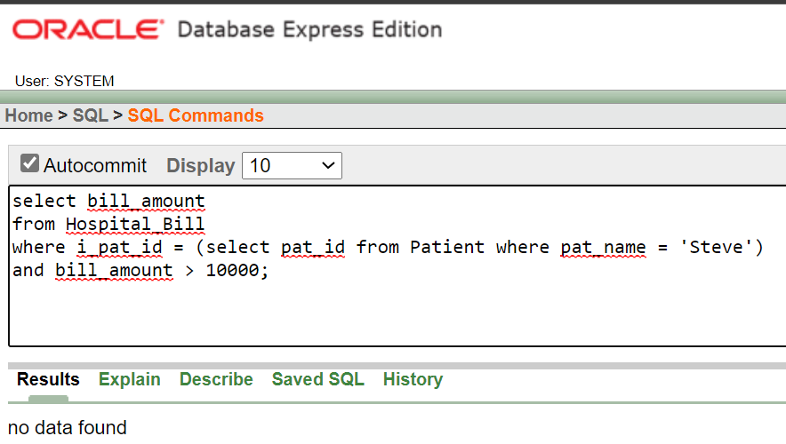

## Find the category and address of the nurse who attended the patient

**with pat_no ‘P220’.**

select category, s_address from Staff where staff_id in (select nurse_id from Appointment where a_pat_id = 'P220');

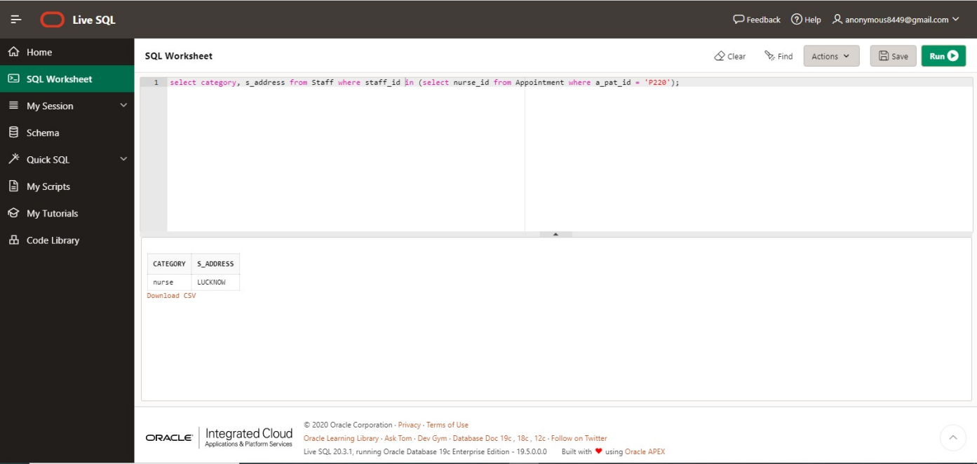

## Find the list of doctors who worked in the department which is started on or after ’10-May-2018’.

select doc_id, doc_name from Doctor where d_dept_no in (select dept_no from Department where estd_date >= '10-MAY-2018');

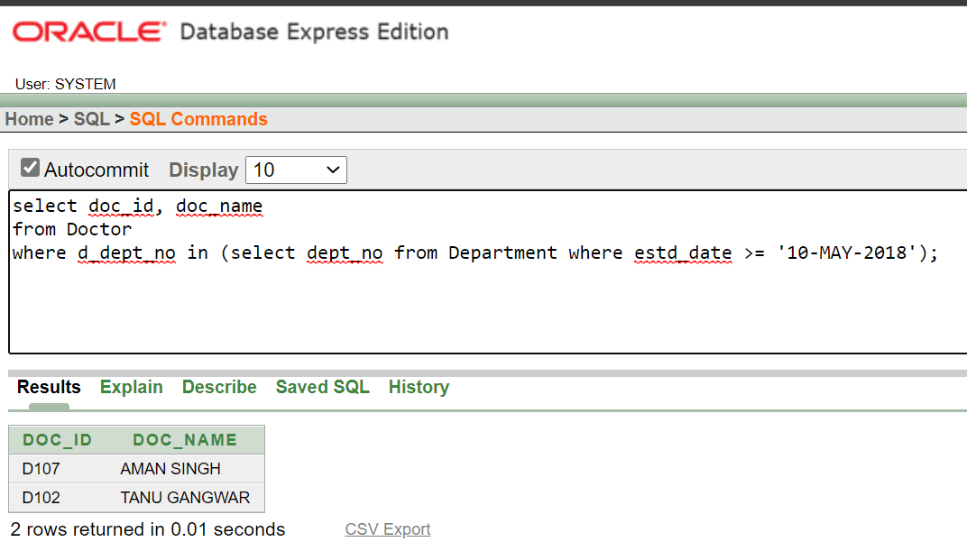

## Get the name of technicians who tests blood glucose level.

select staff_name from Staff where staff_id = (select technician from test_types where description = 'Blood Glucose Level');

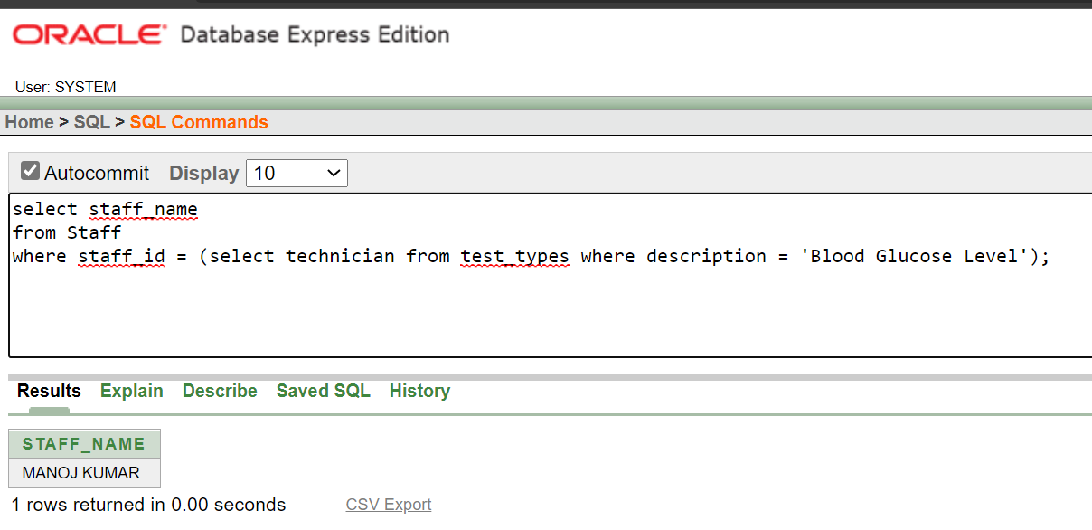

## (i). Display the details of all patients who were hospitalized between ’10- Mar2017’ and ’10-Apr-2017’

select *from Patient where pat_id in (select ip_id from In_Patient where start_time > '10-MARCH-2017' and end_time < '10-APRIL-2017');

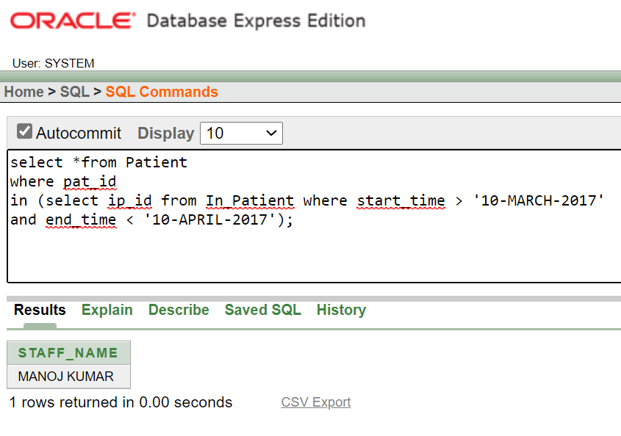

## (j). Display the in-patient prescription of the patient whose name is ‘Gayle’.

select *from In_Patient_Prescription where in_pat_id = (select pat_id from Patient where pat_name = 'Gayle');

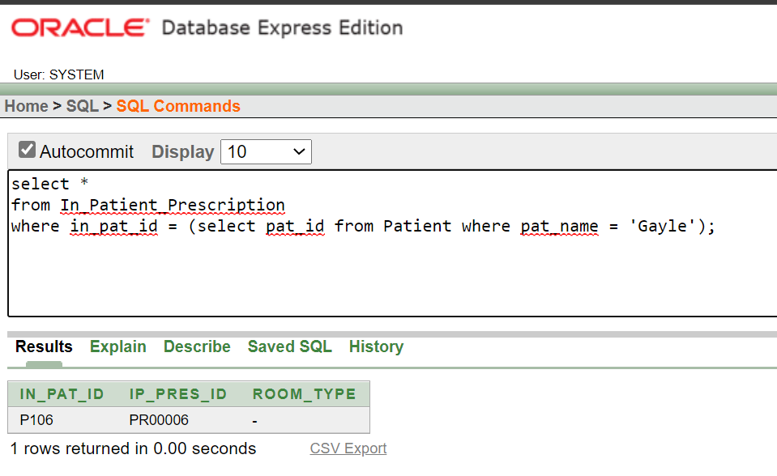

## Find the name and id of all patients who are older than all the doctors in

**the entire ‘cardiology’ department. Use subqueries and ALL operator.**

select pat_name, pat_id from Patient where p_dob < all(select d_dob from Doctor where d_dept_no = 'D101' or d_dept_no = 'D100');

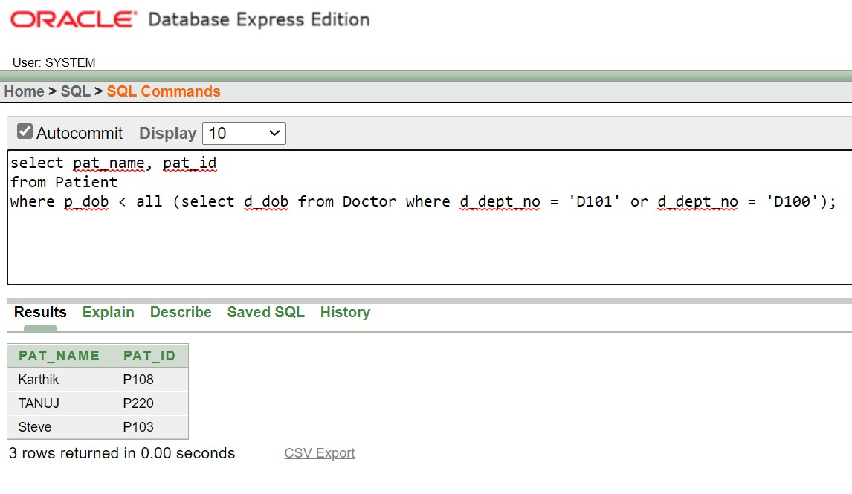

## Find the prescription ids of all prescription that included a medicine

**from the brand ‘Ranbaxy’ using nested subqueries.**

select pres_id from Prescription where pres_id in (select m_pres_id from Prescribed_Medicines where brand = 'Ranbaxy');

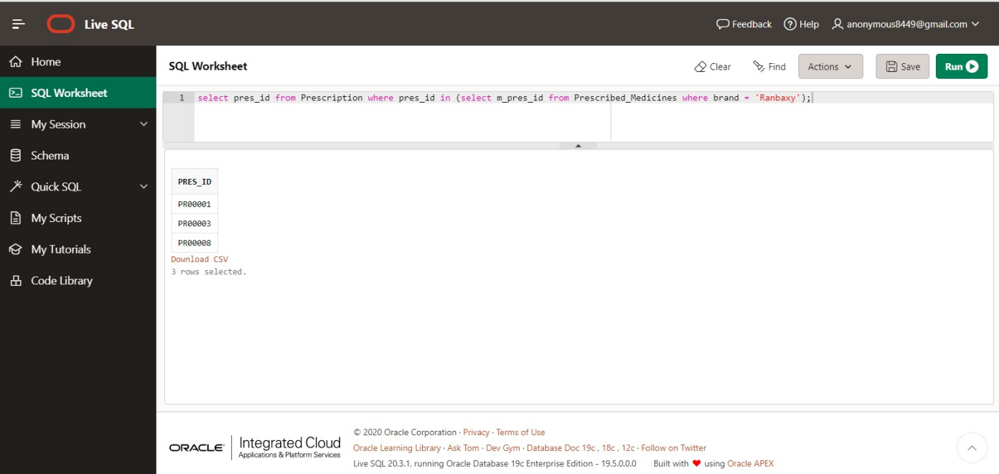

## Find the list of patients who paid their bill through either ‘credit card’ or ‘debit card’ using subquery.

select pat_name from Patient where pat_id in (select i_pat_id from Hospital_Bill where payment_type = 'CREDIT CARD' or payment_type = 'DEBIT CARD');

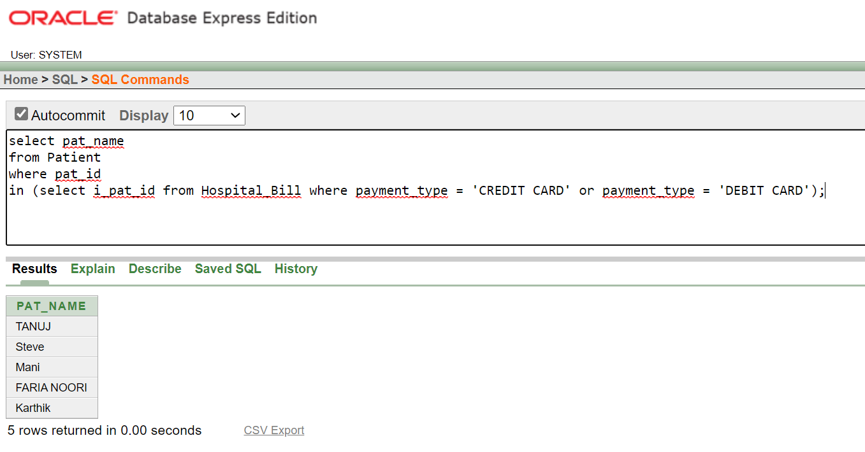

# SQL queries using other functions

## Practice queries using DATE, NUMERIC, and CHARACTER functions. Refer DBMS_Lab_Reference_Material.pdf file. Try to upload at least two queries from each function category.

**DATE FUNCTION QUERIES**

* 1. **Find the last date of month from the established date for a department**

**with department number ‘D101’;**

select last_day(estd_date) from Department where dept_no = 'D101';

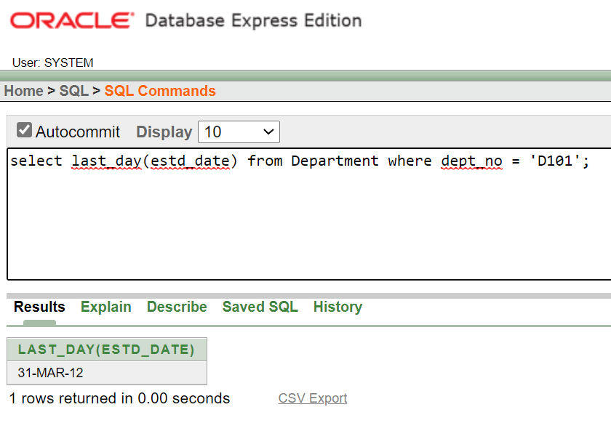

## Find the date after adding 4 months in the date with appointment id

**‘A101’.**

select add_months(a_date,4) as date_after_adding_4_months from Appointment where app_id = 'A101';

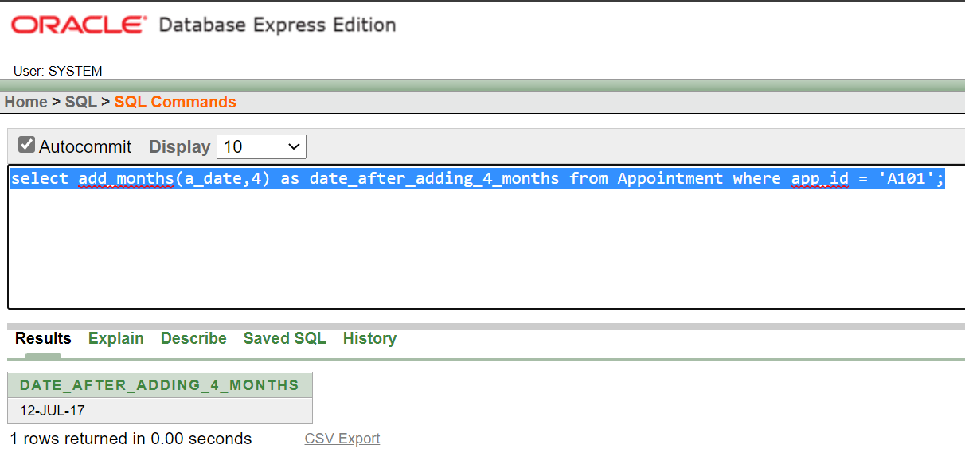

## NUMERIC FUNCTION QUERIERS

* 1. **Find the Square Root of Bill Amount of patient having patient id as**

**‘P101’.**

select sqrt(bill_amount) from Hospital_Bill where i_pat_id = 'P101';

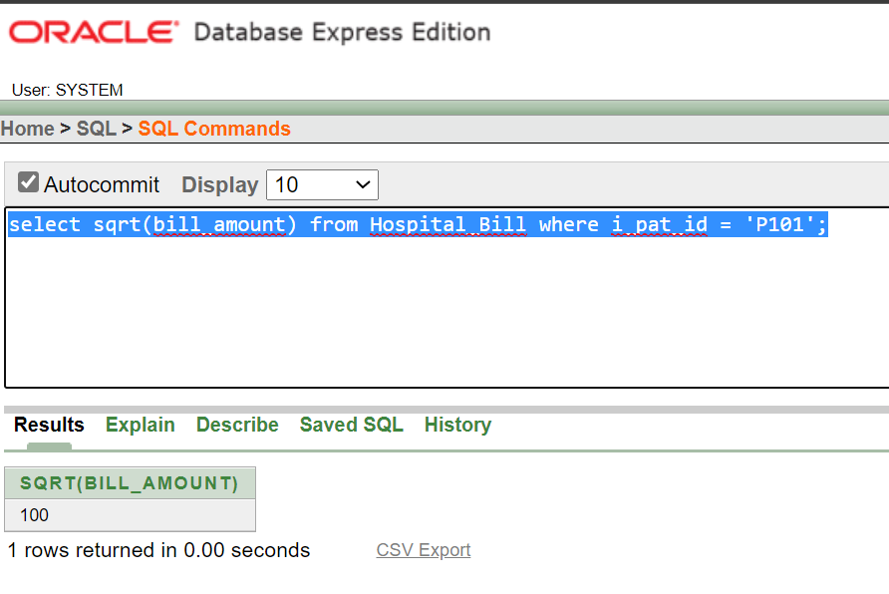

## Find the Absolute Value of Bill Amount of patients.

select abs(bill_amount) from Hospital_Bill;

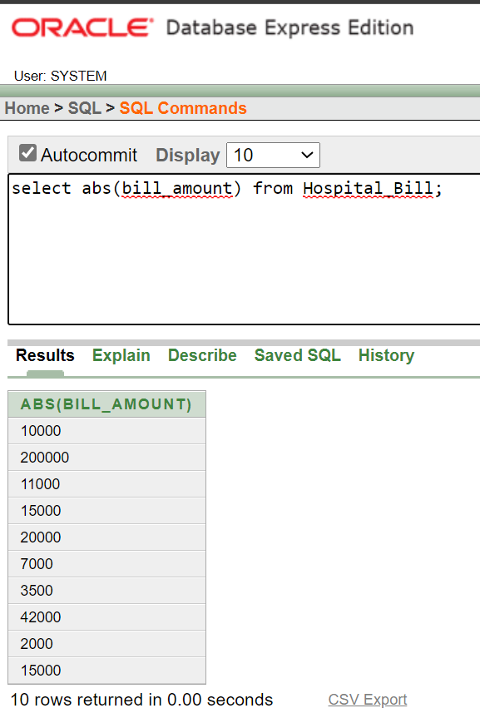

## Find the cos of all bill amounts.

select cos(bill_amount) from Hospital_Bill;

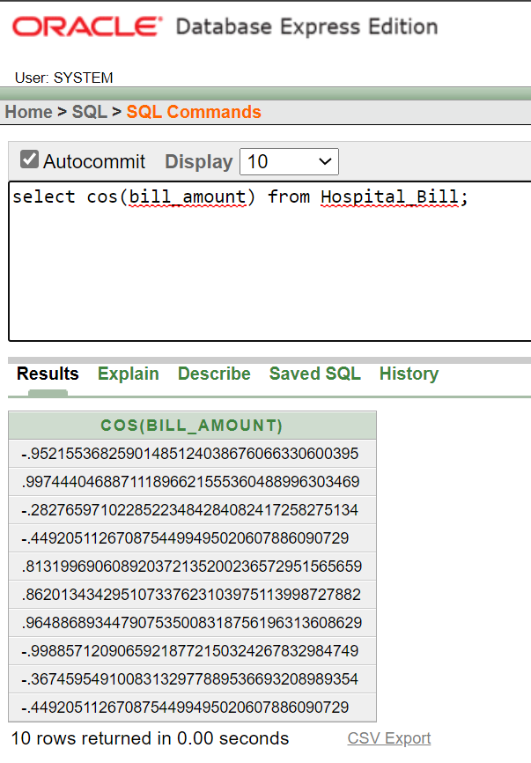

## CHARACTER FUNCTIONS QUERIES

* 1. **Display the Department name in Lower Letters.**

select lower(dept_name) from Department;

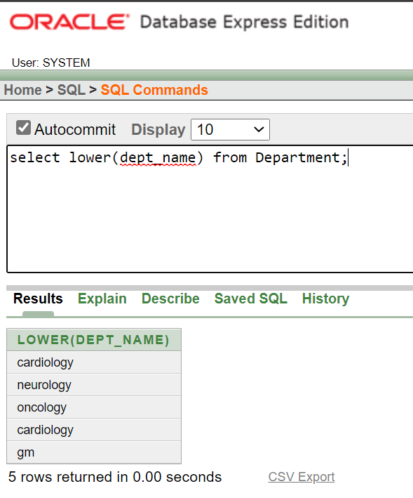

## Display the patient name in Upper Letters.

select upper(pat_name) from Patient;

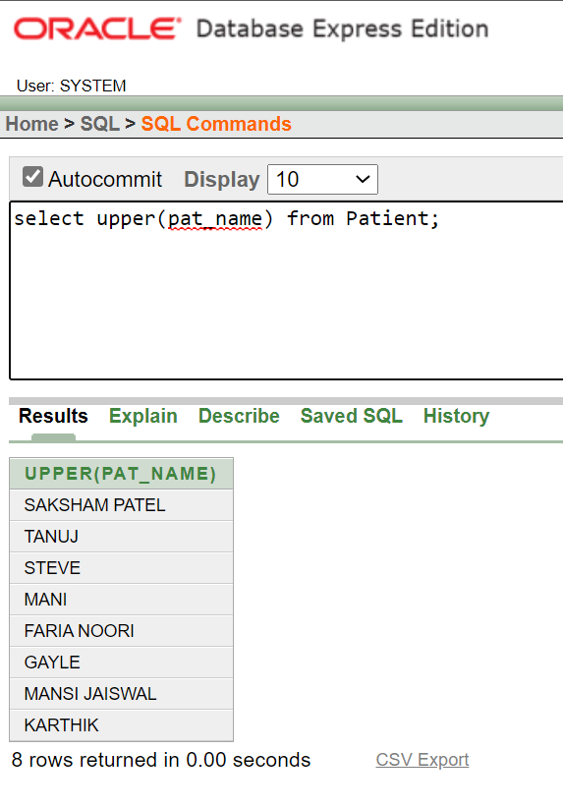

## Concanate the string ‘ GANGWAR’ in the patient having name ‘SAKSHAM PATEL’.

select concat('SAKSHAM PATEL',' GANGWAR') from Patient where pat_name = 'SAKSHAM PATEL';

